Draw Pex pipes for radiator on 2nd floor ( room 3 )
Goal:
- We want to install a new radiator in room 3 on the second floor.
- Some of the work should be done by you (Marius).
- Some of the work will be done by a plumber.

What the plumber will do:
- Fittings, mounting radiator, piping from kitchen to room 3

What we want you (Marius) to do:
- Make pipes accessible in the ceiling of the kitchen by pulling pex piping from bathroom 1 to the kitchen through the entrance/hallway.
- It does not include connecting the new pex pipes to the old iron pipes in bathroom 1
- It also does not include attaching the pex pipes to fittings or the new radiator.

How we expect the work to be done by you (Marius):
- The pex pipes should be pulled in the ceiling so that they are not visible when the ceiling is remounted
- In the below pictures we have attempted to show where we imagine the pipes should be pulled. It is expected that it will be necessary to drill through at least two walls:
- Wall between bathroom and entrance
- From entrance to kitchen
- Ceiling boards will have to be removed in all rooms to be able to pull the pipes and to have space to drill
- It is important that enough piping is pulled that there is spare for the plumber to do his work. Better to have 1 meter too much than a bit too little.

In the below images it is shown where it is expected that the pipes are pulled
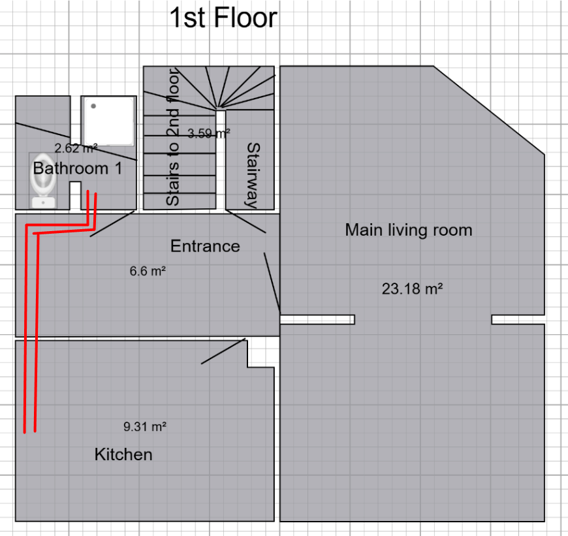 | 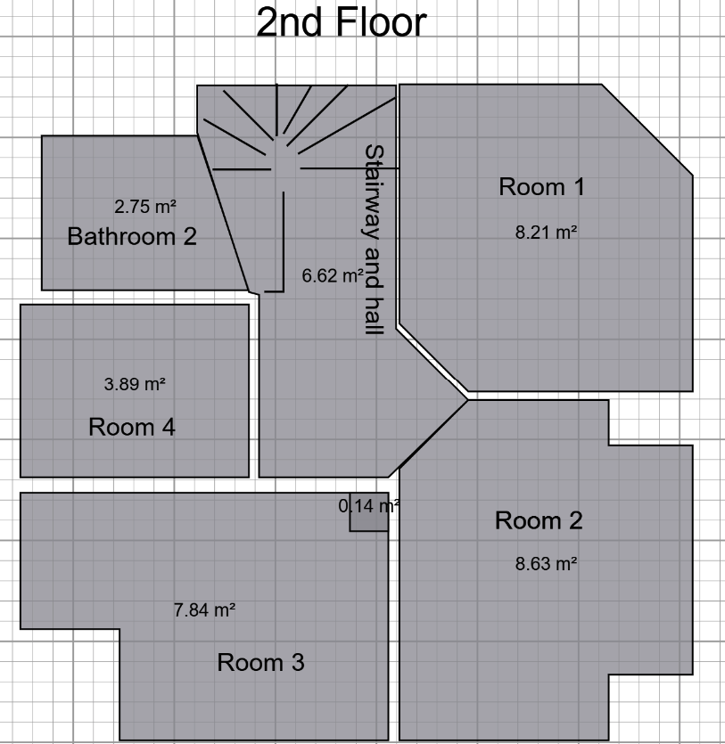

Bathroom 1
Part of the ceiling must be removed here such that it’s possible to pull the pipes up into the ceiling and to drill through the wall to the entrance
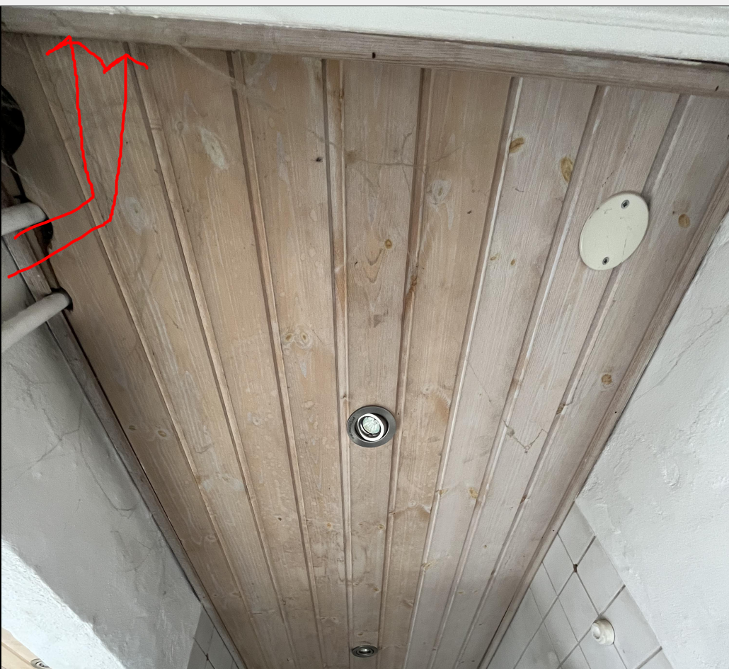

Entrance/hallway
In the entrance/hallway the boards closest to the window must be removed to be able to drill through the wall into the kitchen

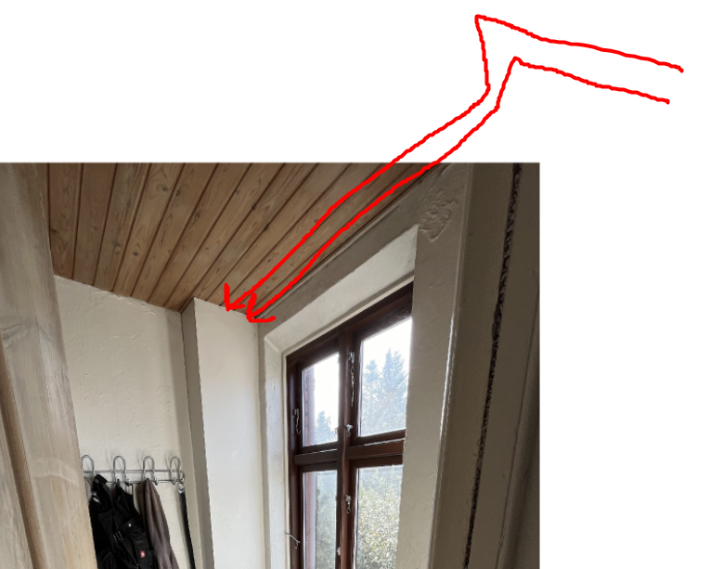

Kitchen
In the kitchen the ceiling boards closest to the window will also have to be removed so that it’s possible to pull the pipes all the way through and a bit further than the windows.
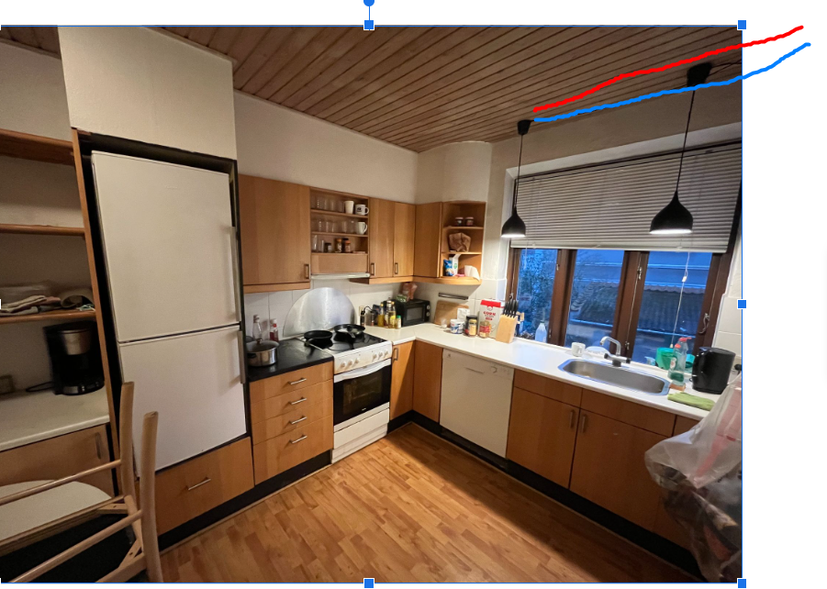

The work stops here as soon as the pipes are available in the kitchen. The plumber will handle the fittings and piping from the kitchen to room 2.

Tools
- Hammer drill
- Multicutter
- jigsaw
- Hand saw (for cutting through pex pipes)

Materials
- Pex pipes - will be delivered to the backyard on Wednesday 5th of november

